**DSIRE Help Guide**

## **Application Version History**

|  |  |  |  |
| --- | --- | --- | --- |
| **Application Version** | **Released On** | **Released By** | **Approved By** |
| 1.0 | 04-09-2020 | N. Padma Gokul |  |

## **Contents**

1. **Introduction 4**
2. **Help Guide 4**

**2.1 Business Term Proposal 4**

**2.2 Business Term Approval 6**

**2.3 Voting Process 11**

# **Introduction**

This document provides step by step information on using the workflow.

# **Help Guide**

## **2.1 Business Term Proposal**

1. Go to Collibra DGC dashboard and click on the button which you configured the proposal workflow with. A form will appear.

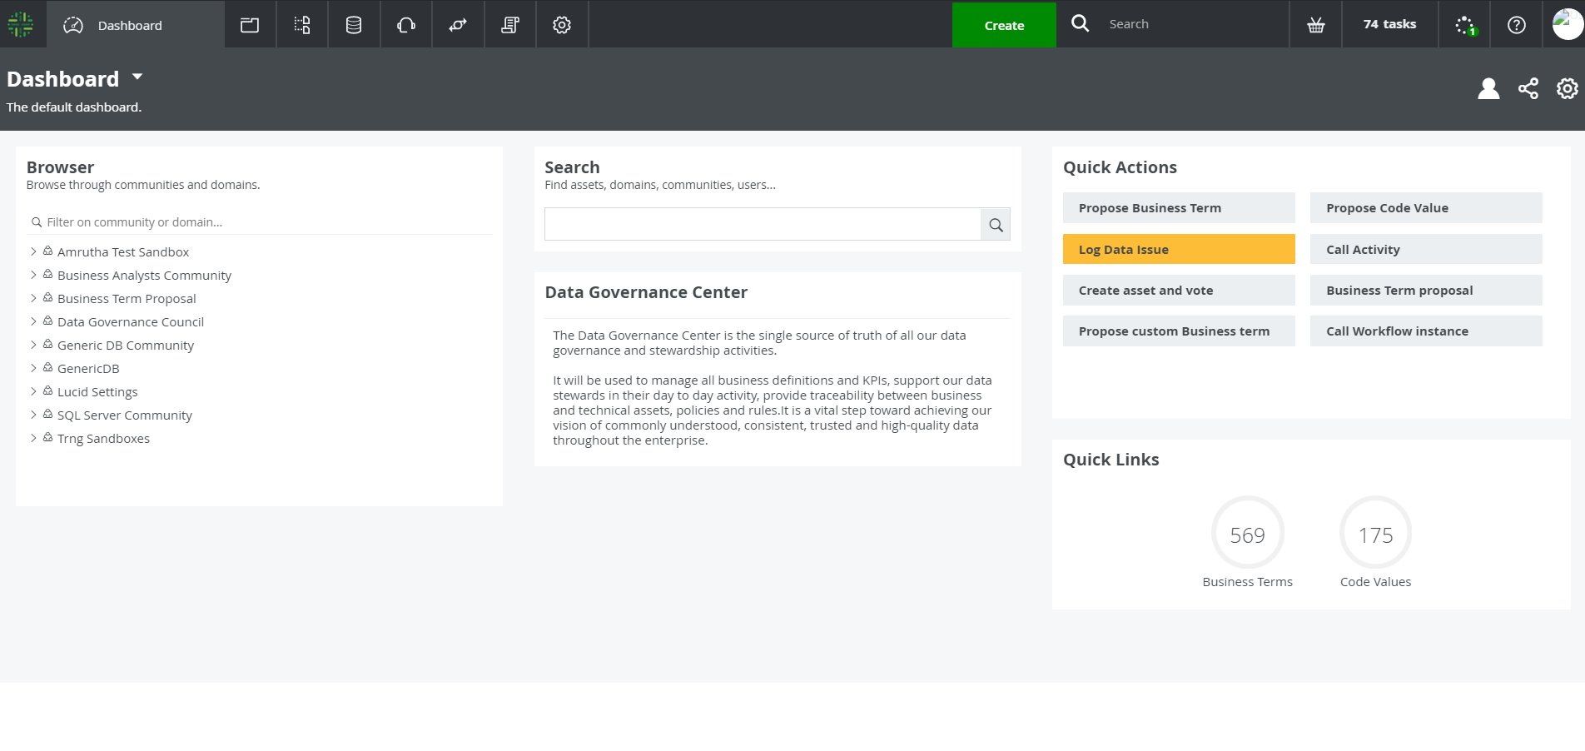

1. Fill in the required fields which are marked with star symbol “ * ”. Click on “Propose” button. Another form appears.

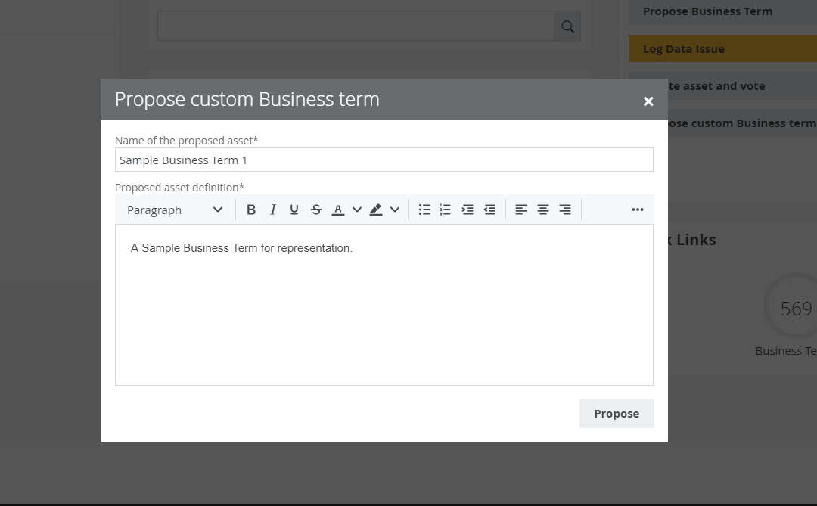

1. Fill in the domain where the business term need to be created and click on “Submit” button.

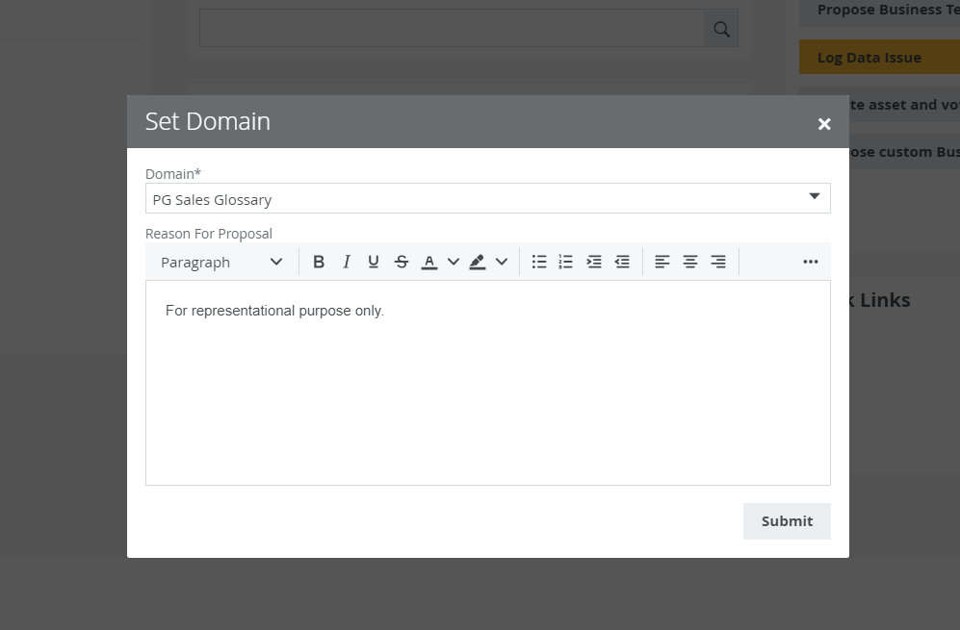

1. A business term will be created in the temporary domain and a task will be assigned to the DG Admins.

## **2.2 Business Term Approval**

1. At first the status of the business term changes to “Under Review” and a task is assigned to the DG Admin. To view the task, go to the DGC Dashboard and click on Tasks on top right corner.

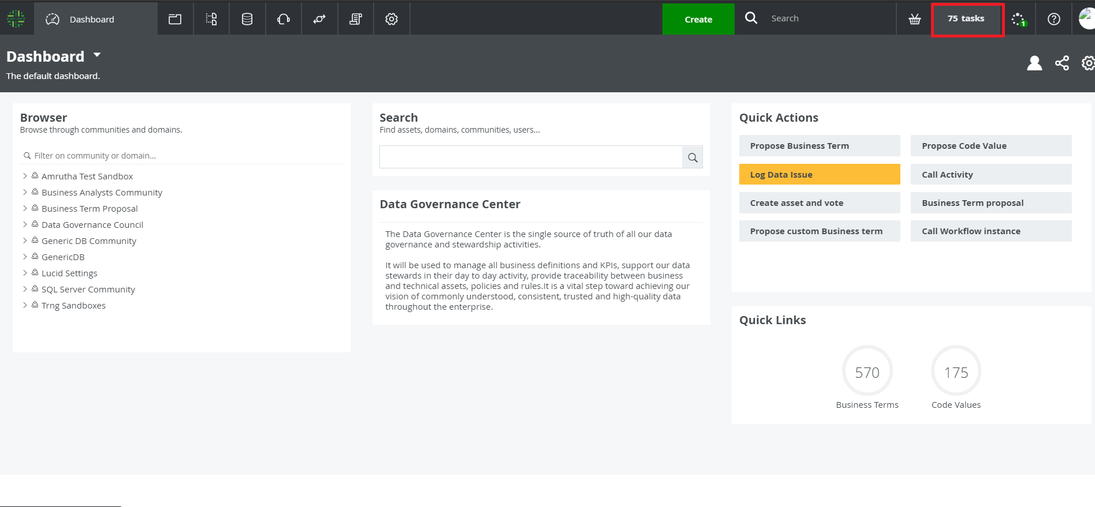

1. Click on “Check Proposed Asset”, the asset page opens. Click on “View Tasks”.

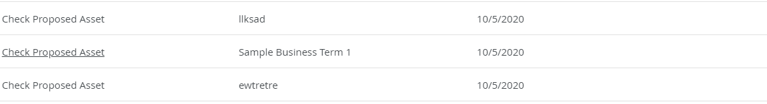

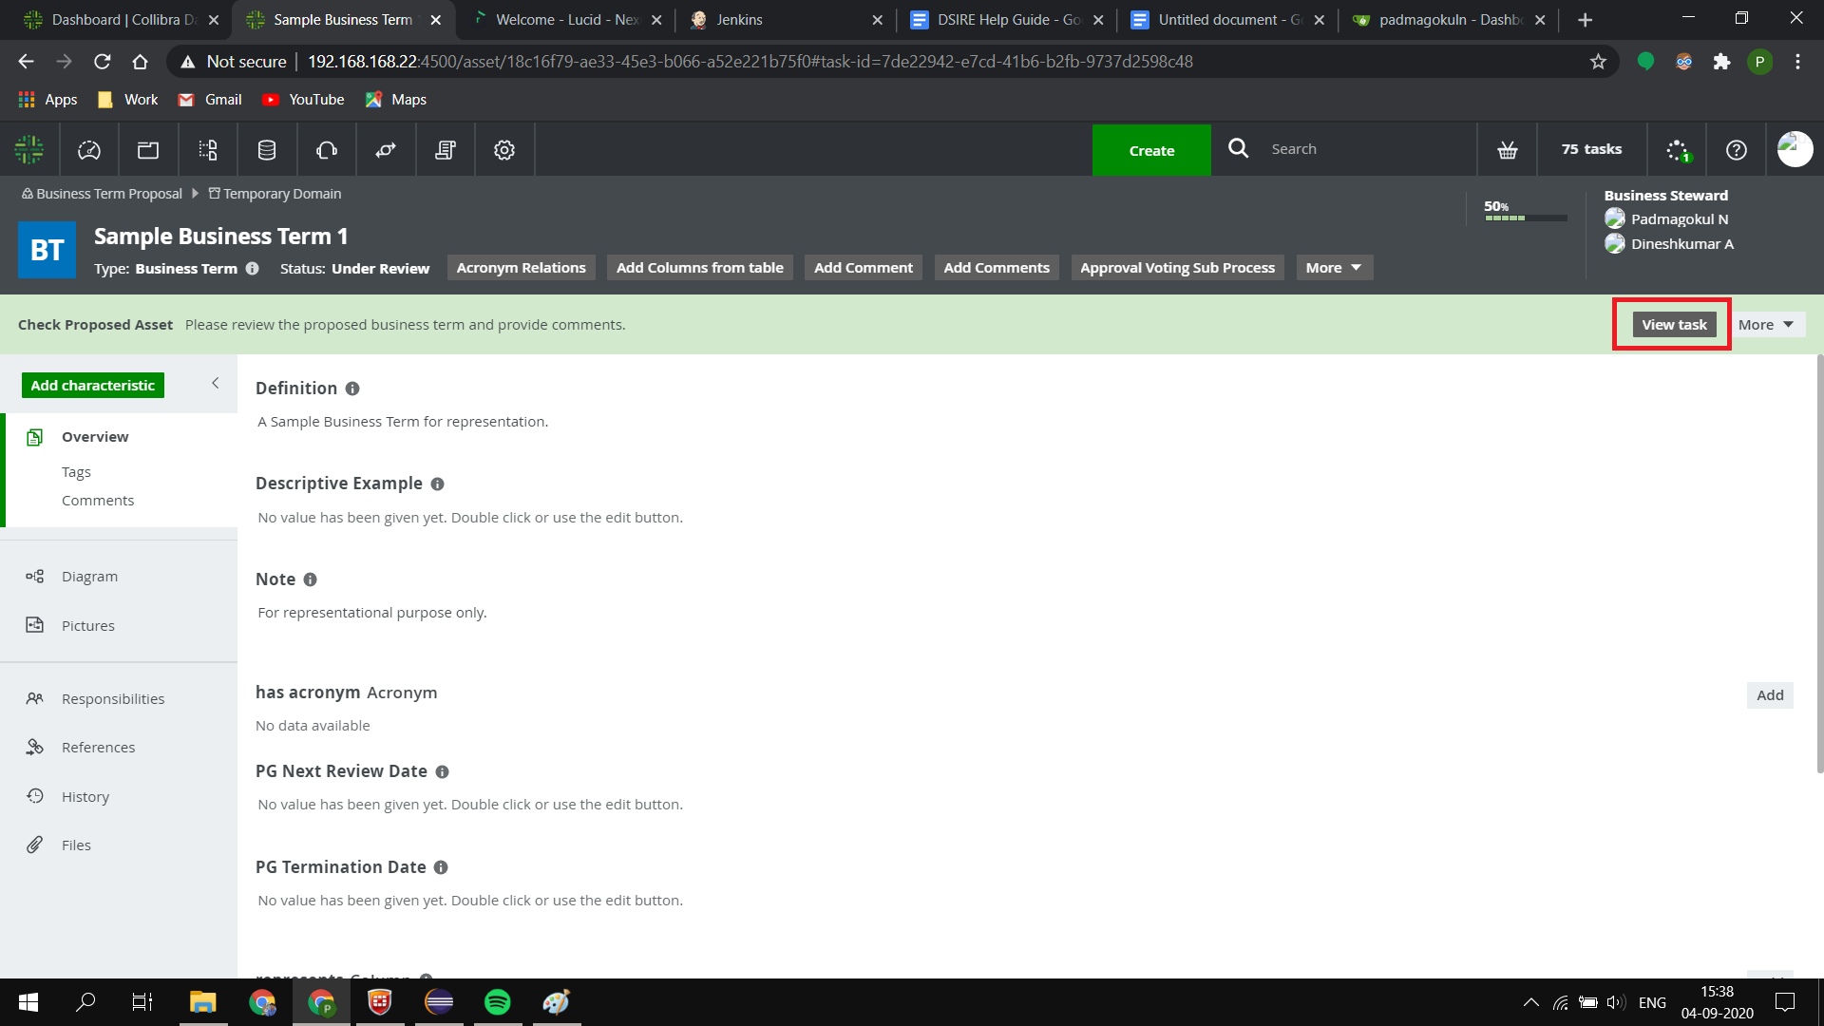

1. A form appears and the values inputted by the proposer is displayed as read-only. Scroll down to add the comments or change the domain if required and click “Approve” or “Reject” button. This task can be completed by any one of the DG Admin. If the DG Admin did not add the comment and click on “Approve” or “Reject” button, then an exception will pop up saying to add comment.
2. After adding the comments, if the Admin accepts the asset, then another task will be assigned to DG Analyst. If rejected, then the status of asset changes to rejected and the process stops.

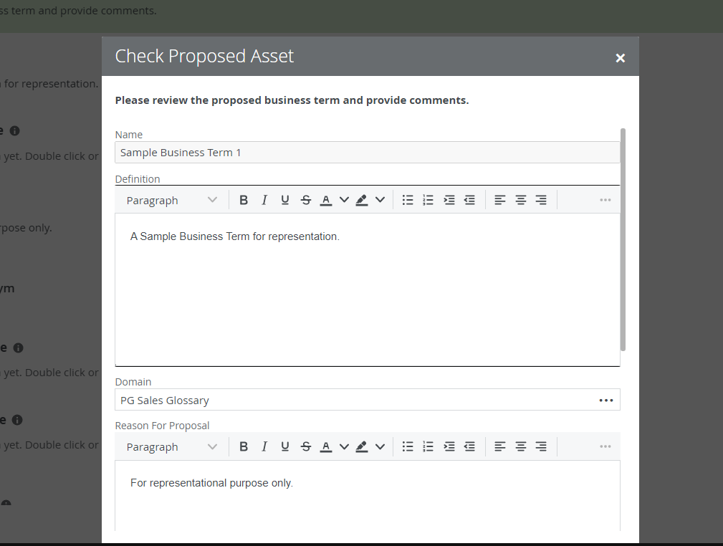

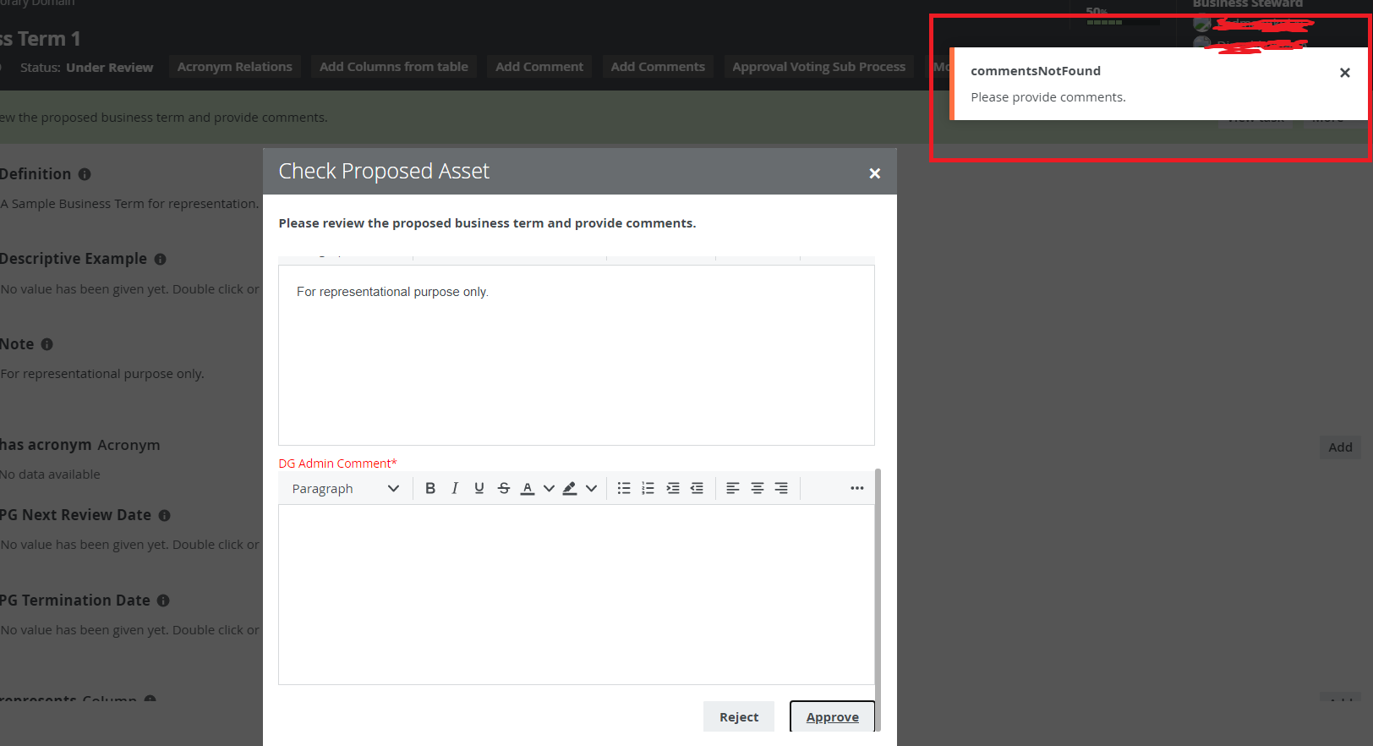

1. The DG Analyst now receives a task and he can access it the same way as DG Admin.
2. A form appears and the values inputted by the proposer and comments by DG Admin is displayed as read-only. Scroll down to add the comments or change domain and acronym to add if present.

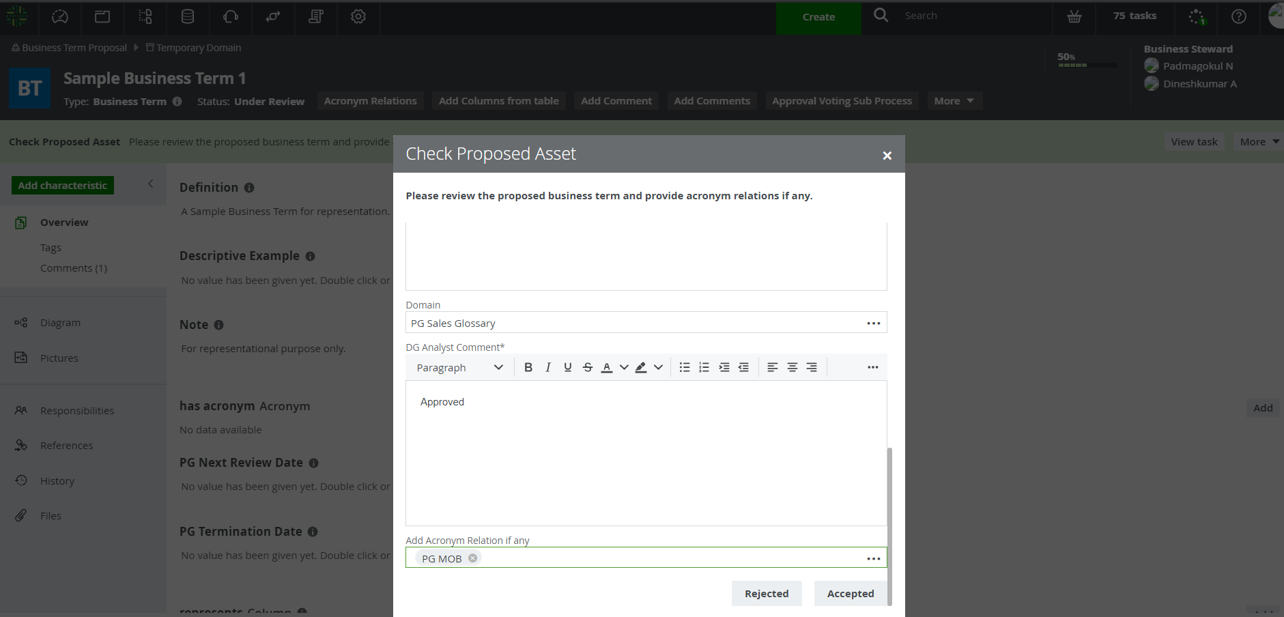

1. After adding the comments, if the Admin accepts the asset, then another task will be assigned to DG Analyst asking them to select tables to add their column to the asset. If rejected, then the task moves back to DG Admin for rechecking.
2. If the acronym is added, it will be reflected in the business term page in “has acronym” section.

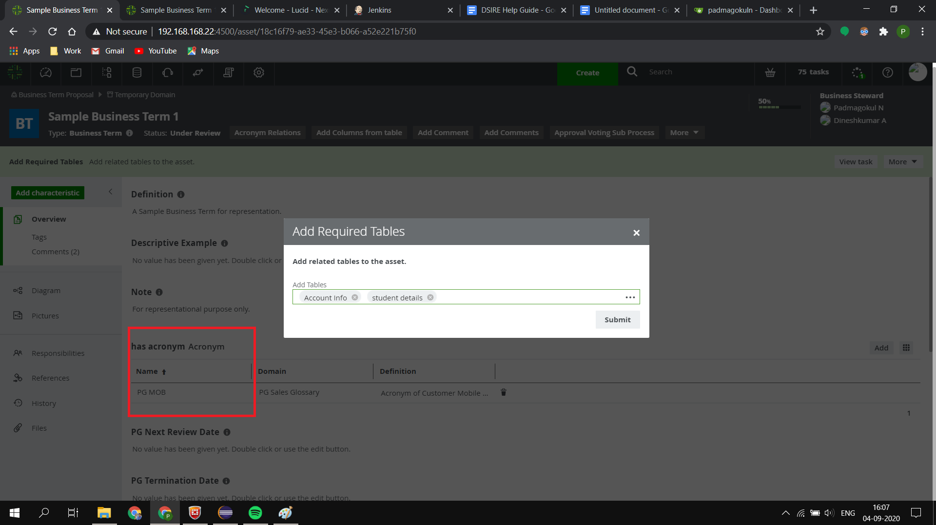

1. After selecting the table, all the columns from the table will be displayed to the Analyst in the next form when the column field is selected.
2. Select the required columns to add from the list. Press submit button.
3. Now another task is assigned to the technical steward asking them to review the selected columns.
4. The Technical Steward now receives a task and he can access it the same way as others.

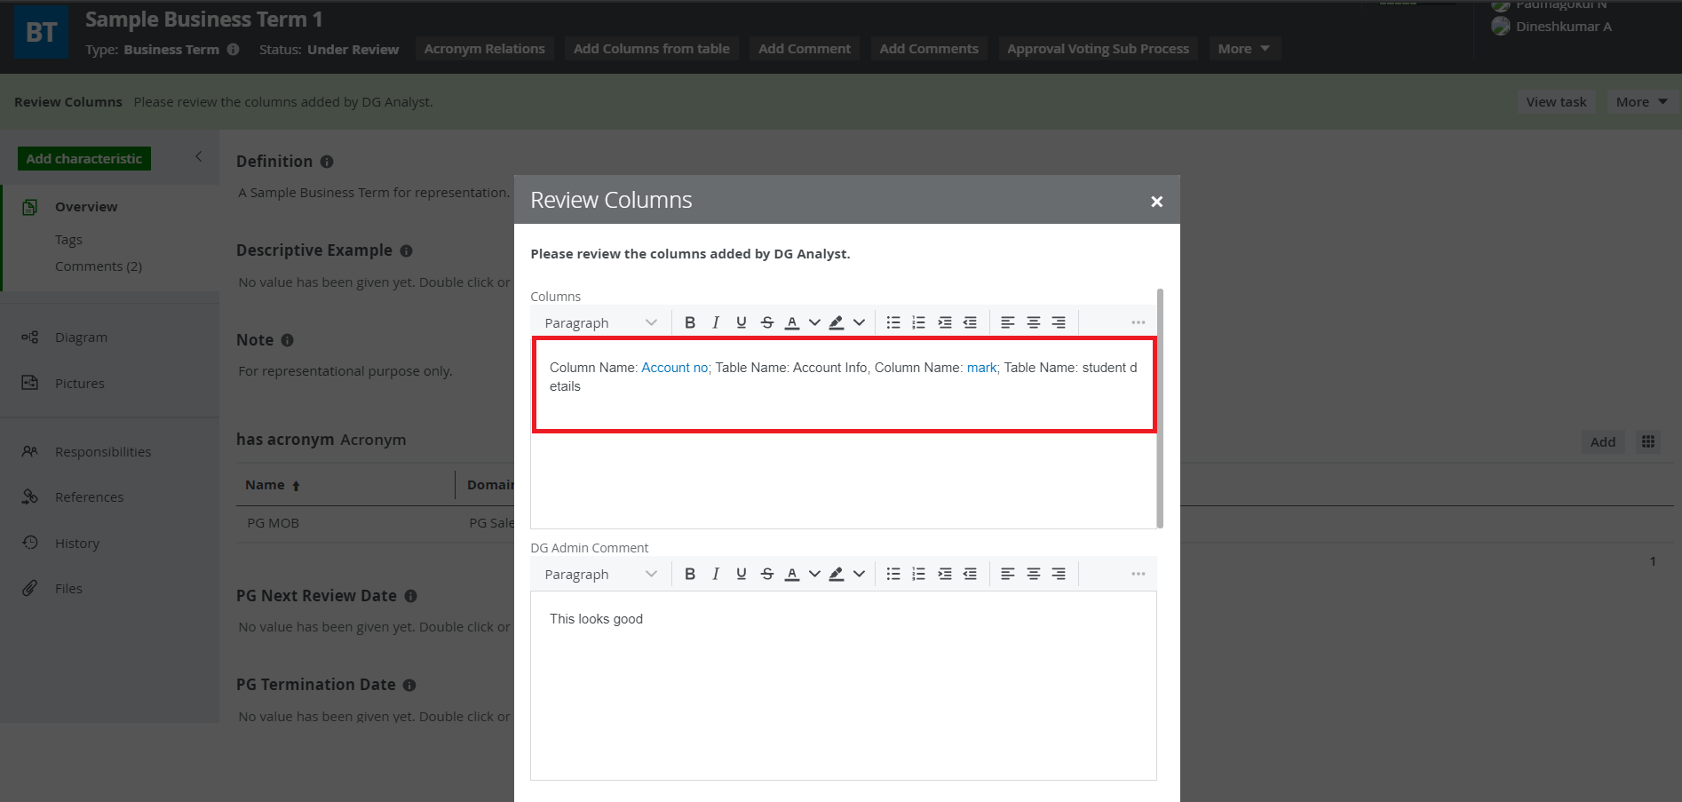

1. They receive a form with the columns added by DG Admin with hyperlink to the column and all the comments by previous users.
2. If the technical steward rejects the proposal, then the process goes back to DG Analyst for recheck.

**Note: After the recheck by DG Analyst, before accepting the asset make sure to remove the Acronym if it was the same one that was added previously to avoid errors. This also applies to the “Select Columns” form. You can add new acronym or column though.**

1. If the Technical Steward accepts the business term, voting process starts and the task moves to Business Stewards.

## **2.3 Voting Process**

1. The Business Steward now receives a task and he can access it the same way as others.

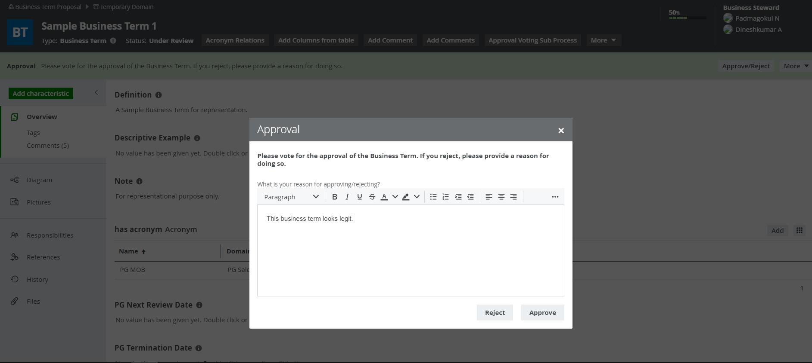

1. They can state the reason to accept or reject the business term. Based on the vote percentage, the business term gets approved or rejected.
2. If the business term gets approved, the status of the business term changes to “Accepted” and the business term moves to the domain last specified by DG Analyst.

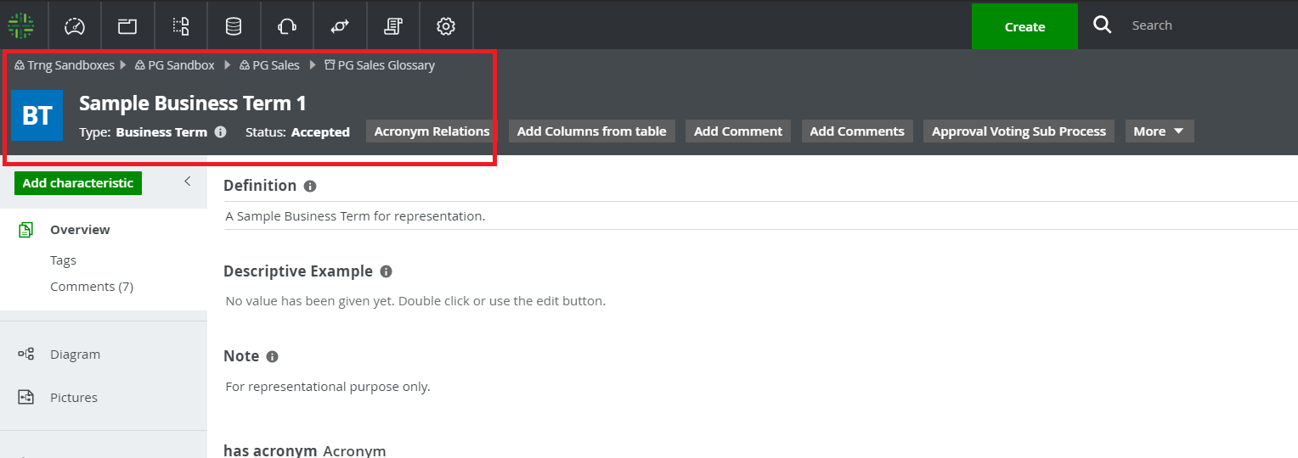

1. If rejected, then the status changes to “Rejected” and the business term stays in Temporary Domain.

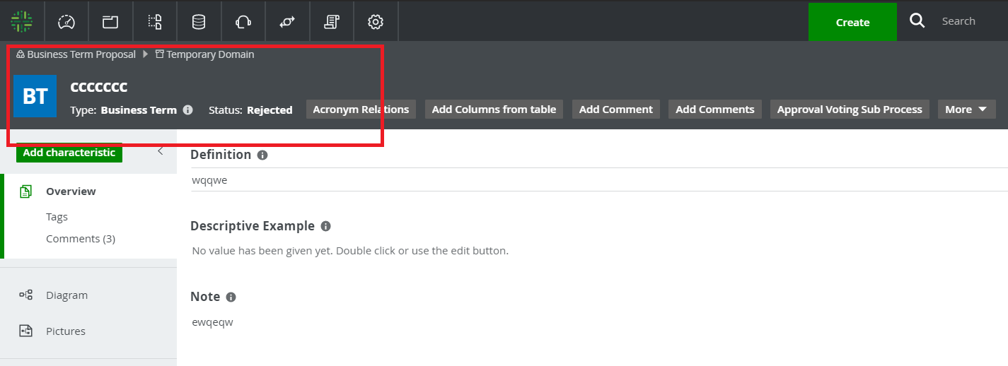

1. It is possible to view all comments made by the approvers by going to asset page and scrolling to “Comments” section.

